|  |  |  |  |  |  |  |  |
| --- | --- | --- | --- | --- | --- | --- | --- |
| Submission Coversheet (All Programmes) | | | |  |  |  |  |
|  |  |  |  |  |  |  |  |
| **Student ID Number**  *(Do not include student name as anonymous marking is implemented)* | RAD18457818  DRO18457544  ANI18457381 | | | | | | |
| **Programme Title** | COMPUTING TECHNOLOGIES | | | | | | |
| **Module Title** | Mobile App Design and Development | | | | | | |
| **Module Code** *(listed on Moodle and in LTAFP)* |  | | | | | | |
| **Module Convenor** | Tendai Mhlanga | | | | | | |
| **Coursework Title** | Barter Trader-Assignment 1 | | | | | | |
| **Academic Declaration:**  *Students are reminded that the electronic copy of their essay may be checked, at any point during their degree, with Turnitin or other plagiarism detection software for plagiarised material.* | | | | | | | |
| **Word Count** |  | | | **Date Submitted** | | **26/11/2019** | |
|  |  | | |  | |  | |
| Please save your file as:  student id_module code_module_title_assessment name  for example: COR15416549_QAB020N592S_Managing Organisations)_Essay 1 Teamwork | | | | | | | |

Table of Contents

**Project Details** 3

Project Name 3

Description 4

**Functional Requirements** 4

Anonymous User - Functional Requirements 4

Registered User - Functional Requirements 4

**Wireframes** 5

**Use Case Diagram** 6

Diagram Design 6

Brief Descriptions of Use Cases 6

**Application Design Model** 7

Architectural Pattern 7

**Class Diagram** 9

Class Diagram Design 9

Description of Classes 10

**Firebase Design** 11

Authentication 11

Cloud Firestore 11

Cloud Storage 11

**Project Implementation** 11

Project Structure 11

Source Code 11

**Marketing Strategy** 11

**User Interface** 12

Main View 12

Select Category Gadgets 12

Select Category Clothes 12

Select Category Tools 12

Select Category Bikes 12

Select Category All 12

View Selected Product 12

Barter for Selected Product 12

View Reviews on Selected Product 12

View User’s products on Selected item 12

View Products’ Photo 12

View Products’ Video 12

Main Menu Selection 12

Sign in Page 12

Sign in –Reset Password Page 12

Sign up Page 12

About Page 12

Contact Page 12

My Account 12

Profile Page – View Profile 12

Profile Page – User’s Reviews 12

Products – View User’s Products 12

Products – View Product 12

Offers – View Received Offers 12

Offers – View Offer 12

Reviews – View User’s Accepted/Rejected Offers 12

Reviews – View and Set Review for Accepted/Rejected Offers 12

Add Product 12

Add Product Page 13

Add Product – Select Category 13

Add Product – Select Photo 13

Add Product – Select Video 13

Add Product 13

**Test Documentation** 13

**Appendix:** 14

**References:** 14

# 

# **Project Details**

## Project Name

Barter Application

## Description

The Project Barter App

Mecachrome Software Ltd has employed us for creating a new application called ”Barter Trader”. The purpose of the app is to provide a platform to facilitate the barter (exchange) of goods among users who wish to barter various items like clothes, gadgets, tools, toys, bicycles etc.

# **Functional Requirements**

## Anonymous User - Functional Requirements

* Can view products by category in a grid arrangement
* Can view a product
* Can sign in, after registration
* Can read About, contact, terms and conditions of the application when the person decide to register.
* An anonymous can not register without accepting terms and conditions of the app

## Registered User - Functional Requirements

* Can login into a different account;
* Can register a new account;
* Can sign out
* Can recover the password
* Access His Account information:
* View Profile- including his first name, surname, telephone number, alias, email address, rating, if user is a flagged one-negative feedback and average number of the rating from other users. When rating falls below zero and the user is flagged more than 5 times, the user can no longer add new items and cannot message other users.
* View his Products-including image and title; if the user click on his product than he can see image of his product, recording, title and description
* View His Offers
* View reviews- on this page user has the option to add reviews of the user who posted the item for barter and to message the user;
* Each category lists the same gadgets;
* Add a product -including image, video, title, description of the item and option available to choose the right category
* Can read reviews from other users
* Can login to their accounts using their unique email address and password
* Can read About, contact, terms and conditions of the application when the person decide to register.
* Add a product including image, recording, title and description and option to choose the categories
* View the categories- From the Dashboard, when a category of item is selected (**Gadgets, Clothes, Tools, Bicycles, Others)**, the user is taken to a list of items for barter in that category
* - Categories listed for logged and anonymous users are: Gadgets, Clothes, Tools, Bicycles, Others;
* If users are selecting one of the four categories than all gadgets are displayed in a scrollable list allowing for navigability of the list;
* - The object of class Categories are dynamically read from a firebase database and then set on the activity;
* Details of each item/gadget will include: description of the item, rating of the user who posted the item, option to list all the items that this user whose item the logged user is currently viewing;
* If user is interested in the item and want to offer something in the exchange of it than user is able to message the other user with his/her offer;
* If the users agree with the barter than status of the items is changed to agreed;
* Once the item status is changed to agreed it is no longer listed in the application;

**Non-functional requirements:**

* When user get a call in the same time when he is using the app, then when he opens the app he should log in into his account;
* When user is adding a new product, he is acknowledged with message: “Product added successfully”
* When user open the app, it is loading within 10 seconds in such way that user doesn’t have to wait too long for app to respond

# **Wireframes**

# **Use Case Diagram**

## Diagram Design

//TO DO insert Use Case Diagram

## Brief Descriptions of Use Cases

//TO DO briefly describe each use case

# 

# **Application Design Model**

## Architectural Pattern

We’ve chosen the Model-View-View Model (MVVM) architectural pattern because Google embedded this pattern into the Android’s framework so that developers can easily implement their logic into mobile applications. Beside the ease of use, it is one of the architectural patterns which enforces separation of concerns, which divides the user interface from the business logic. The advantages of this is that the code is easy to maintain by dividing the work to frontend and backend developers, it is simple to isolate, and unit test the components and least but not last the reusability and extensibility of the classes increases the implementation speed of the project.

As seen in the figure below the implementation is divided into three layers:

* Model:

This layer represents the business logic of the application and exposes its data through the framework’s own observable data holder class, called LiveData. Beside triggering data changes, the model also contains entity classes used for structuring the data in the application and in the database. The Model also contains Firebase instances of its different clients for requesting and receiving data from the Google’s Servers.

* View Model:

The View Model manages the Model components and provides references of the observers to the View components. Aside this, it also provides methods for passing events to the business logic. The whole idea behind the View Model is to decouple the View components from the implementation logic of the application. Android’s framework facilitates this through the ViewModel class, which is lifecycle aware and because of this allows data to be persistent even if views change their state.

* View:

The View layer only manages updates on Activity and Fragment classes with the help of their Adapters and View Holders. On this layer the View components observe for data changes in the Model and update the user interface accordingly. It also triggers events for the Model through the View Model in order to get data changes.

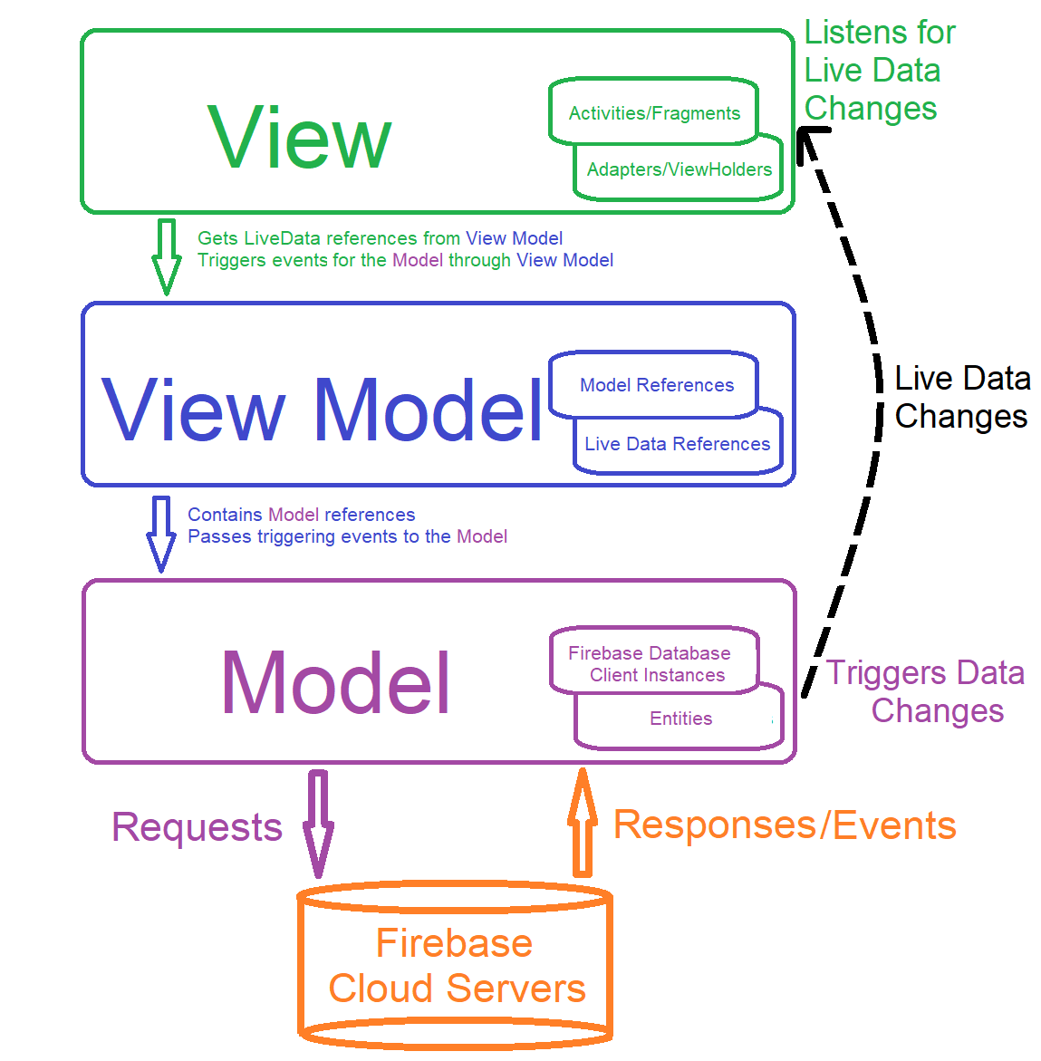

**Class Diagram**

Class Diagram Design

### Description of Classes

Because the system is designed as a MVVM architectural pattern and the number of classes surpasses 50, the description of the classes will be divided into Model/View/View Model categories and the common descriptions of the classes will be gathered under each group.

**View Classes**

All Activity classes extend from the AppCompatActivity and override some of the lifecycle call-back methods like onCreate(), onResume(), onDestroy. In the onCreate() method we only initialize, populate and set listeners for the UI elements, create the required view models, get the references of the exposed LiveData objects and create observers for them. In the onResume() method we only trigger events for refreshing the data in the UI elements.

Because of the complexity of the project we’ve used fragments which extend from the Fragment class and at least override onCreate(), onResume(), onCreateView, onAttach(), onDetach().The onCreateView() method is used in the fragments classes to have access and inflate its layout and also populate and set listeners to the UI elements. The onAttach() and onDetach() methods are also used in fragments to set/unset the base activity’s listener. To trigger events to the base activity, the fragments contain inner public interfaces which must be implemented by the activity in order to receive click events.

Beside static views, the project also has dynamic lists of UI elements, because of this the views use the RecyclerView UI element to list items with the help of adapter classes. This adapter classes extend from the RecyclerView.Adapter<> abstract static class and contain an inner class which extends from RecyclerView.ViewHolder abstract static class. The adapter classes are used to hold and manage the data collections, and the inner view holder classes are used to set and manage the view elements. The adapters of fragments use the fragment’s inner interface as a listener to trigger click events to the base activity, and the adapters of activities have their own inner interfaces to trigger the click events.

|  |  |
| --- | --- |
| **Class Name** | **Description** |
| MainActivity | It is the launcher activity, and it exposes the products categories through a Tab Layout in a two columns grid Recycler View. The class contains adapters for each category, allowing to set the filtered group of products whenever the tab is selected. Also, there is the option to directly add a product through a Floating Action Button, view product details or access the main menu. From the main menu you can login, register, view account information, add a new product, sign out, access the about or contact page. |
| ProductsAdapter | It is used by the MainActivity class to manage the products by category. It contains a list of Product class entities and handles the RecyclerView layout in its ViewHolder inner class. |
| ViewProductActivity | This activity shows the added date, title, description, image and/or video thumbnail of the product, and the user’s alias, average ratings as a rating bar UI element with a floating value and the total number of flags it has. From this view the logged in user can view the user’s reviews, products and can barter with the user. The anonymous user is restricted to interact in this activity, he can only view the page’s content. |
| ReviewsActivity | It receives the user reviews through its intent and shows them as a list in its recycler view. It uses the ReviewsAdapter class to manage the reviews. |
| ReviewsAdapter | It contains a list of UserReview class entities, and it is used by the ReviewsActivity class to handle the user’s reviews. |
| UserProductsActivity | It is used to list the user’s products. It receives the user id through its intent in order to query for products in the database by id. Each product can be viewed in detail by clicking on it. |
| UserProductsAdapter | It contains a list of Product class entities and it is used by the UserProductsActivity class to handle the user’s products. |
| OfferActivity | The activity is used to make an offer on the selected product to the item owner. It receives the user id, product id and product’s image Uri through its intent in order to tie the newly created offer to the user’s product. It also adds the email and the offeror’s message to the new offer. |
| ViewImageActivity | This activity gets the image URI of the product from its intent and shows it with the help of the Picasso Library in an ImageView element. |
| ViewVideoActivity | This activity gets the video URI of the product from its intent and loads the video in a VideoView element with a MediaController. Because the Video is usually downloaded slowly there is a ProgressBar element which shows that it is loading. |
| AddProductActivity | This activity can only be used by logged in and unrestricted users. In order to insert a product into the database the user must add an image, set a title and a description of the item, and can add a video and select a category. The activity shows the video and the image after selection as a thumbnail in their ImageView containers. The categories are loaded in a Spinner element from the strings.xml file found in resources folder. |
| LoginActivity | It is used to login as a registered user with email and password, or to recuperate the user’s password. When the user presses the log in button, the email and password TextView elements are checked for validity and then signs into the account. |
| RegisterActivity | It is used to register for a new account with first name, surname, telephone, alias, email and password. When the user presses the register button, all the text fields mentioned above are checked for validity and checks if the terms and conditions have been agreed by selecting the CheckBox element. |
| ForgotPassActivity | It is used to reset the user’s password by email. |
| TermsAndConditionsActivity | It is used to read the terms and conditions of the application. |
| AboutActivity | It is used to read some information about the project. |
| ContactsActivity | It is used as a contact page in which you can find information on how to contact the company. |
| AccountActivity | It is the base activity for the ProfileFragment, MyProductsFragment, OffersFragment and ReviewsFragment. It implements the fragments’ inner interfaces as listeners to react to certain click events inside their views. It contains the SectionsPagerAdapter in order to handle the fragments when the TabLayout element is pressed. |
| SectionsPagerAdapter | The class is used to manage the tab selection in the TabLayout element and load the fragment holder according to the tab index. It extends the FragmentPagerAdapter abstract class and overrides the getItem(int), getPageTitle(int) and getCount() methods. |
| ProfileFragment | The fragment is constructed as a singleton class, used to show user’s profile details like reviews average value, number of flags, first name, surname, telephone, alias and email. To show all this information it requests data through the ProfileViewModel and ViewReviewViewModel classes. |
| MyProductsFragment | The fragment is constructed as a singleton class, used to show the logged user’s products by id. It uses the MyProductsViewModel class to query for data and the MyProductsRecyclerViewAdapter to contain and show the products. |
| MyProductsRecyclerViewAdapter | It contains a list of Product class entities and it is used by the MyProductsFragment class to handle the user’s products. |
| ViewMyProductActivity | It shows the added date, title, description, image and/or video thumbnail of the product, and the user’s alias. |
| OffersFragment | The fragment is constructed as a singleton class, and it lists the user’s received offers. To show the received offers it requests data through the MyOffersViewModel class. It uses the OffersRecyclerViewAdapter class to manage and show the offers. |
| OffersRecyclerViewAdapter | It contains a list of Offer class entities and it is used by the OffersFragment class to handle the user’s received offers. |
| ViewOfferActivity | It shows details of the offer like product’s image, offeror’s alias and email. The offer can be refused or accepted through predefined buttons. The offer is loaded from it’s intent and it changes the state of the entity in the database through the ViewOfferViewModel class. |
| ReviewsFragment | The fragment is constructed as a singleton class, and it lists the user’s accepted or rejected offers. To show the offers’ history it requests data through the MyOffersViewModel class. It uses the ReviewsRecyclerViewAdapter class to manage and show the rejected or accepted offers. |
| ReviewsRecyclerViewAdapter | It contains a list of Offer class entities and it is used by the ReviewsFragment class to handle the user’s accepted or rejected offers. |
| ViewReviewActivity | This activity shows the user’s review on the accepted/rejected offer. It uses the ViewReviewsViewModel class to fetch the current review of the offer. If the offer doesn’t have yet a user review it will show as an initial state with nothing set or inserted in the review. User can modify the review even if it is already set. The user can change the user rating bar and value, the review and a Switch element representing if the receiver is flagged or not. |

**View Model Classes**

|  |  |
| --- | --- |
| **Class Name** | **Description** |
| ViewModelFactory |  |
| ProductsViewModel |  |
| LoginViewModel |  |
| RegisterViewModel |  |
| ForgotPassViewModel |  |
| MakeOfferViewModel |  |
| AddProductViewModel |  |
| ProfileViewModel |  |
| MyProductsViewModel |  |
| MyOffersViewModel |  |
| ViewOfferViewModel |  |
| MyReviewsViewModel |  |
| ViewReviewViewModel |  |

**Model Classes**

|  |  |
| --- | --- |
| **Class Name** | **Description** |
| AuthentificationModel |  |
| ProductsModel |  |
| OffersModel |  |
| ReviewsModel |  |
| UserProfile |  |
| UserReview |  |
| UserReviewAggregationData |  |
| Offer |  |
| Product |  |
| Response |  |

# **Firebase Design**

## Authentication

## Cloud Firestore

## Cloud Storage

# **Project Implementation**

## Project Structure

## Source Code

# **Marketing Strategy**

Site mapping

# **User Interface**

A UX **strategy** is the plan and approach for a digital product. UX **strategies** help businesses translate their intended **user experience** to every touchpoint where people interact with or **experience** its products or services (<https://medium.com/@MentorMate/what-is-user-experience-strategy-7af34d694fbb>)

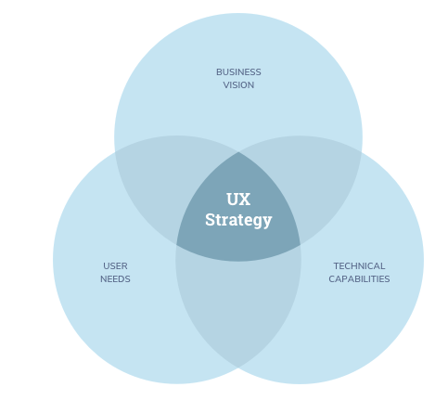

## Colour psychology and emotional associations.

Colours can provoke emotions for many people. Many popular companies have used colour psychology in marketing to evoke a particular emotion in their customers. We have chosen orange color for Title Bar. Orange is associated to confidence, success, bravery and sociability and this is the reason for choosing orange. Purple colour chosen for add button express royalty, luxury, spirituality and ambition. White colour chosen for background relates to emotions as clean, simplicity, innocence and honesty and black colour is associated to formality, dramatic, sophistication, security. (<https://www.usertesting.com/blog/color-ux-conversion-rates/>)

## 

## Main View

### Select Category Gadgets

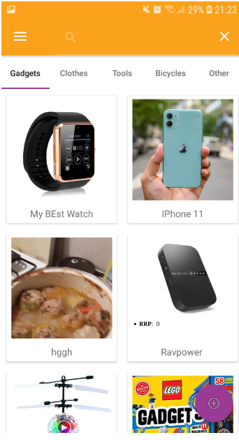

### 

### Select Category Clothes

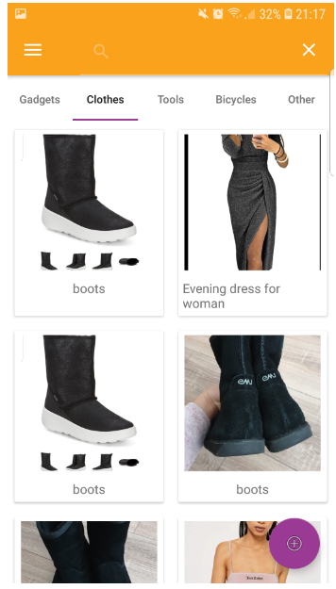

### Select Category Tools

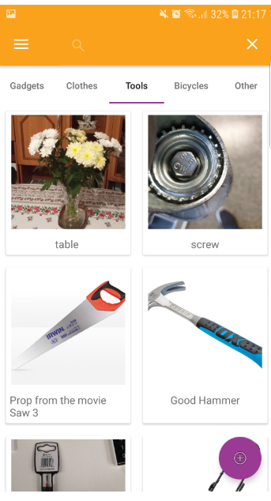

### Select Category Bicycles

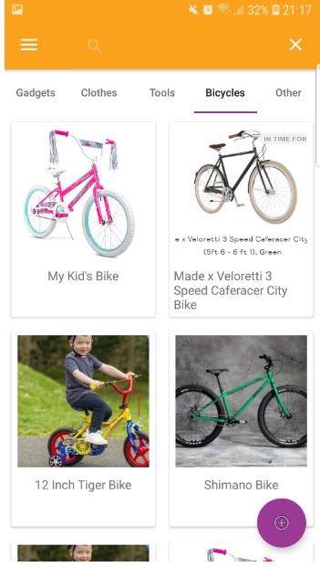

### Select Category Others

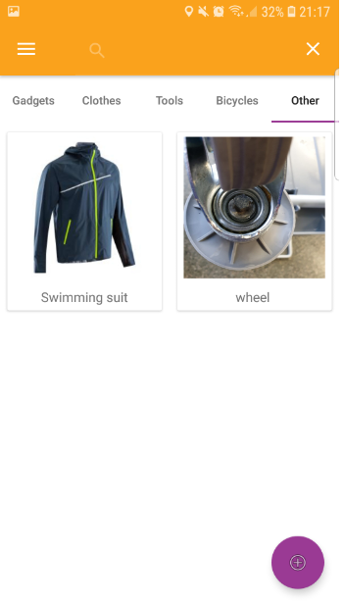

## View Selected Product

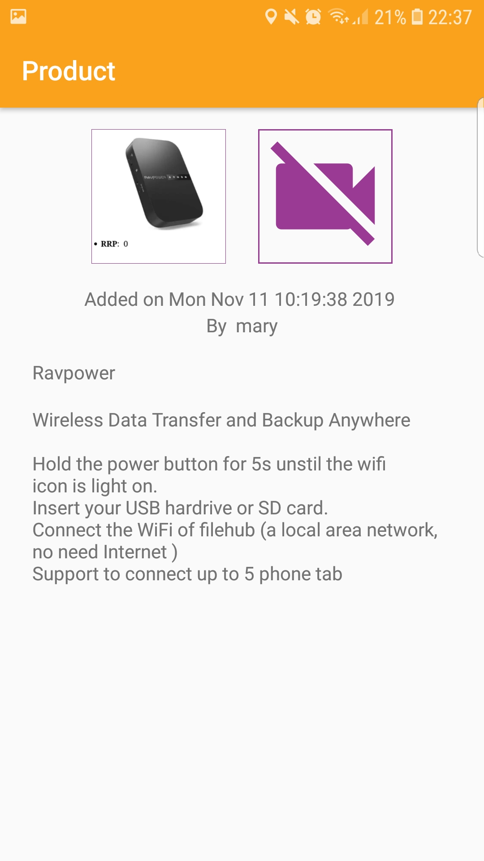

### Barter for Selected Product

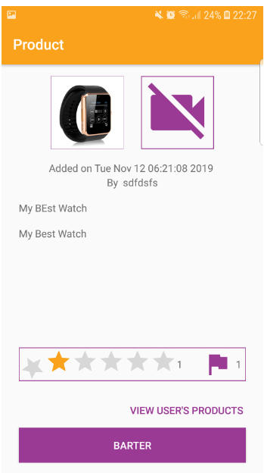

### View Reviews on Selected Product

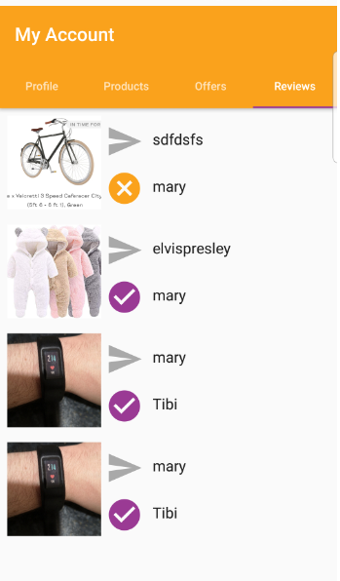

### View User’s products on Selected item

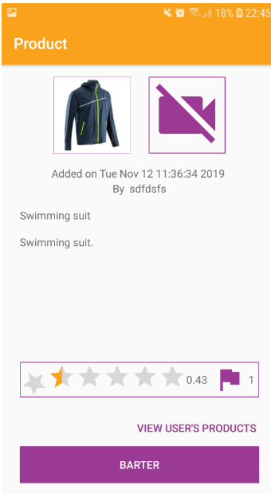

View Products’ Photo

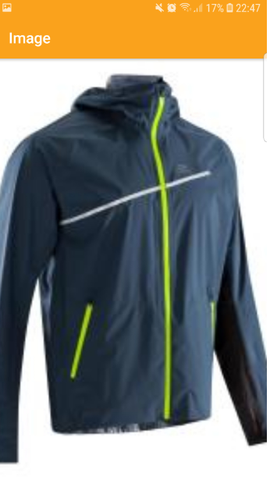

### View Products’ Video TO DO

## Main Menu Selection

### Sign in Page

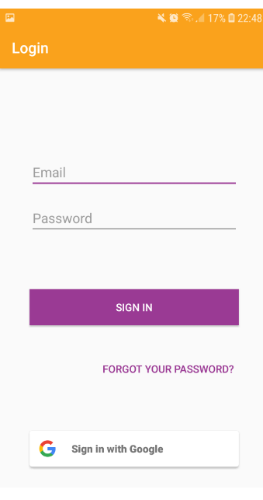

Sign in –Reset Password Page

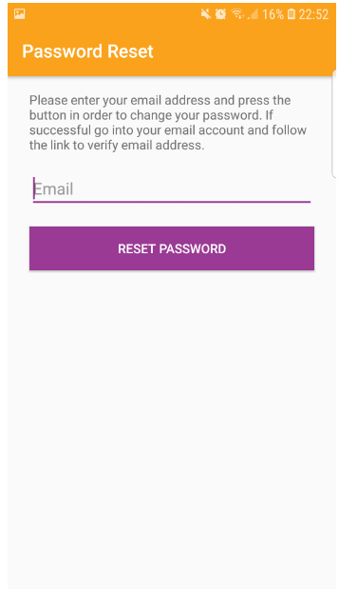

Sign up Page

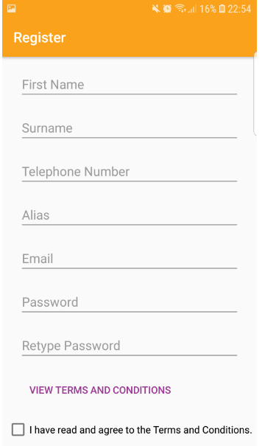



### About Page

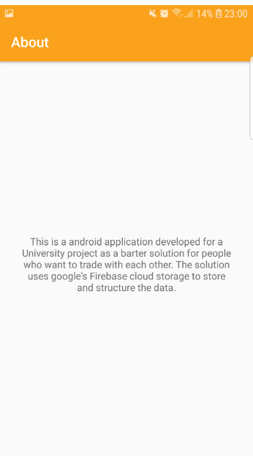

### Contact Page

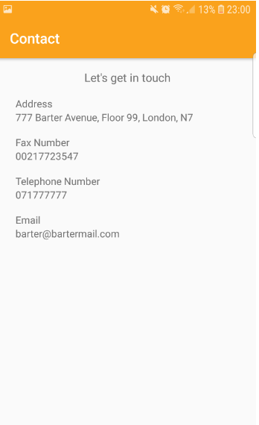

## My Account

### Profile Page – View Profile

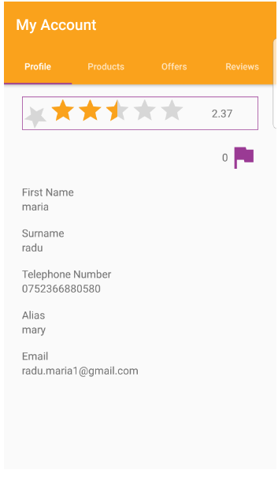

### Profile Page – User’s Reviews/ Write user’s review

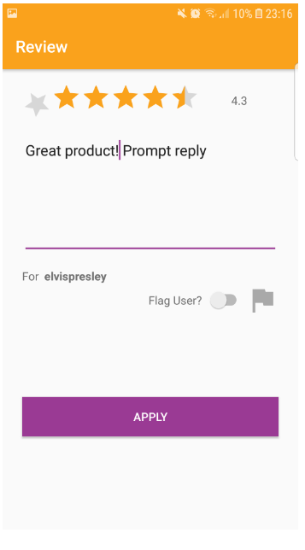

### Products – View User’s Products

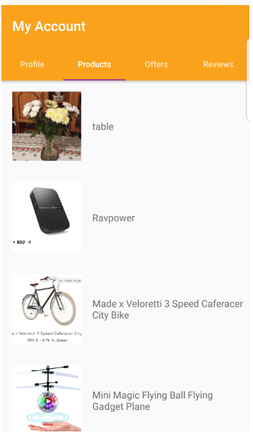

### Products – View Product

### Offers – View Received Offers

### Offers – View Offer

### Reviews – View User’s Accepted/Rejected Offers

### Reviews – View and Set Review for Accepted/Rejected Offers

## Add Product

//TO DO show both options of adding a product(from menu and from button)

### Add Product Page

### Add Product – Select Category

### Add Product – Select Photo

### Add Product – Select Video

## Add Product

# **Test Documentation**

# Verification or testing – is involving testing of the features as per the functional requirements to make sure that all the requirements are met.

|  |  |  |  |
| --- | --- | --- | --- |
| **Description** | **Input** | **Output** | **Result** |
| Start Application | Tap the application’s icon. | The application starts in the main view showing the products under the gadgets category. | Successful |
| Register |  |  |  |
| Sign in |  |  |  |
| Sign Up |  |  |  |
| Sign out |  |  |  |
| About |  |  |  |
| Contact |  |  |  |
| Add Button |  |  |  |
| Categories |  |  |  |
| Add Product |  |  |  |
| Search item |  |  |  |
| Flagg user |  |  |  |
| Rate user |  |  |  |
|  |  |  |  |
|  |  |  |  |
|  |  |  |  |
|  |  |  |  |
|  |  |  |  |
|  |  |  |  |
|  |  |  |  |
|  |  |  |  |
|  |  |  |  |
|  |  |  |  |

# **Appendix:**

# **References:**